**Recipe: 3**

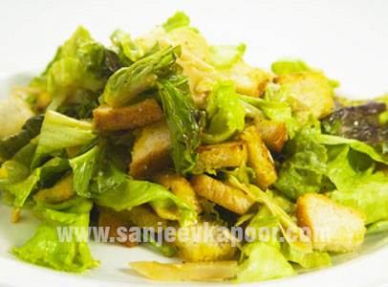

**Caesar’s Salad -** Assorted lettuce salad dressed with homemade mayonnaise and served with crispy croûtons.

Italian cuisine has developed through centuries of social and political changes, with roots stretching to antiquity. Italian cuisine is simple and a number of dishes having only four to eight ingredients. They rely mostly on the quality of ingredients rather than elaborate preparation.

Noteworthy changes in Italian cuisine happened with the discovery of the New World and the introduction of potatoes, tomatoes, bell peppers and maize, which are now an integral part of this cuisine. Italian cuisine is known for its regional diversity each with a distinct taste. This cuisine today is probably one of the most popular in the world.

**Prep Time : 16-20 minutes**

**Cook time : 0-5 minutes**

**Serve : 4**

**Level Of Cooking : Easy**

**Taste : Mild**

**Ingredients for Caesar’s Salad Recipe**

1. Bread Slices 100 grams
2. Oil 1 tablespoon
3. Lollorosso lettuce hand torn 1/2 bunch
4. Basil leaves hand torn 5-6
5. Garlic peeled and crushed 2 cloves
6. Bread slices cut into 1 inch cubes 2
7. For dressing
8. Iceberg lettuce hand torn 1/2 bunch
9. French mustard paste 1 teaspoon
10. Worcestershire sauce 1 teaspoon
11. Extra virgin olive oil 2 tablespoon
12. Salt to taste
13. Black peppercorns crushed 1/4 teaspoon

**Method**

Step 1

Heat oil in a pan and add garlic. Add the bread cubes and sauté till bread pieces are a little crisp and browned at the edges. Remove and keep aside.

Step 2

Heat sufficient water in a pan, bring it to boil, add eggs and boil them for two to three minutes only. Keep the lettuce leaves in a big bowl.

Step 3

Add the basil leaves, bread pieces and garlic and toss lightly. Make cheese shavings using a peeler and add to the bowl or else grate the cheese and ad. Break the lightly boiled eggs into another bowl and whisk well.

Step 4

Add mustard paste, Worcestershire sauce, olive oil, salt and freshly crushed peppercorns and whisk till well blended. Add dressing to the salad and toss lightly. Serve immediately.

Nutrition Info

Calories : 1111 Kcal

Carbohydrates : 84 gm

Protein : 16.9 gm

Fat : 78.6 gm

Other : Iron- 6.8mg